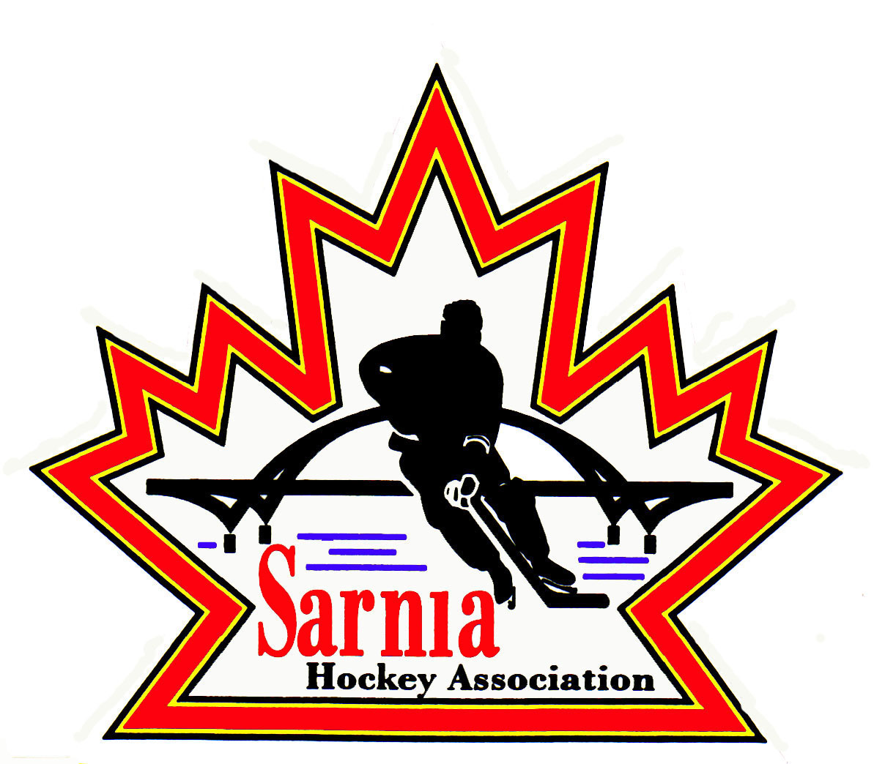

Sarnia Hockey Association

Minutes | Date: APRIL 1, 2025 | time 7:00 pm

Meeting called by | Paul Walsh, President
Type of meeting | Regular
Secretary | Kelly Lane, Recording Secretary

Welcome | Paul Walsh, President, and meeting Chair welcomed everyone and called the meeting to order at 7:08 pm.

ATTENDANCE | Heather Amaral, Andrew Beasley, Jacquie Beasley, Jerry Bernardo, Alister Brown, Emily Brown, Paul Douglass, Ian Dunn, Chuck Ewart, Jeff Fogal, Pat Forbes, Terry Gray, Dan Hunt, Kelly Lane, Linda Lauzon, Don McGugan, John Mellor, Kyle Mellor, Blake Morrison, David Penner, John Ritchie, Wayne Scarrow, Jason Teather, Barb Walsh, Paul Walsh  Regrets: Darren Chevalier, Bonny Marcy, Ted Pendle, Tim Turner

ACCEPTANCE OF MINUTES | MOTION #250401-001  “That the Minutes from March 19, 2025, be accepted as presented.” ( J. Ritchie/J. Mellor)  Carried  Add Director of Recreational League U13 under 1-year appointments.

TREASURER’S REPORT | - This is the final month of our fiscal year end. All bills to be submitted by April 28.  - If able to delay expenses for the next season, please do so.  - Reviewing final ref and timekeeper bills.  - Waiting on ice bills and photography bill.  - Jamboree registrations – some team payments are still outstanding.  - For team accounts, budgets and bank statements are being submitted to parents and Vice President of Administration for review.  - We will be shuttering the accounts as soon as they are empty. Making changes as we transition to next season. We learn each year and will make some fine tuning to the process.  - Since we are now allowing tryout registrations from outside of Sarnia, there is no way to have capacity to e-transfer in time for players stepping on the ice. Must use credit card to register for tryouts. We don’t want players to show up saying that they have paid by e-transfer and it hasn’t been reconciled. They cannot be on the ice without payment.  - As soon as rep players are given an offer to be on the team, they have until 4 pm the next day to go into the system and register with Sarnia Hockey. The cost will be $2000. If after budget has been approved, it is less, than it will be refunded. They can still do a payment plan for this. They can choose e-transfer or credit card, Setting up for 6 payments.  - This allows us to have Rec and Rep separate for registration.  - There is a lot of change happening and still anticipating more change happening.  - Did prepare financial report but we don’t have bank statements yet.  - Still some significant outstanding bills but we are in good shape financially.

BILLS TO BE PAID | MOTION #250401-002  “That the bills be paid as presented.” ( E. Brown/Bernardo)  Carried
  Recipient | Expense | Amount
  March Bills:  U15 Select Team  Dark Horse Goaltending  Team Outfitters  Planet Stitch  All Seasons Trophies  Alliance  Sarnia Ice Hawks Sledge  Jeff Fogal  Ian Dunn  April Bills:  Dark Horse Goaltending  6x4 Goaltending  All Seasons Trophies  Big Daddies  Alliance  Silver Stick  Emily Brown  Bluewater Referee Association | 50% reimbursement for Alliance Championships  March 14 Goalie Clinic (Cousi funded)  End of Season Director gifts  Coach Gifts  Executive Jacket  Year-end rewards for U16-21  Jamboree Awards  Final Days medals  House League Championships registration fees- teams will reimburse SHA 50%  Game Sheets for Rec League  Donation for room use for photos  Winter Classic expenses  Ref Director expenses  Cousi funded  Cousi funded  Year End awards  Final Days meals. Note they reduced bill by $500 to help with player assistance.  50% reimbursement to U9 T1, U9T2  U13 BB, U14BB, U15BB  Post dated cheque for 2025/26 pins  Admin costs (Quick Books subscription, printer ink)  Goalie Equipment reimbursement (Cousi funded)  Referee costs | $ 610.00  $ 450.00  $ 2,000.10  $ 1,850.38  $ 103.96  $ 167.24  $ 266.68  $ 6,335.91  $ 7,800.00  $ 250.00  $ 500.00  $ 20.33  $ 364.00  $ 450.00  $ 600.00  $ 435.62  $ 8,313.14  $ 600.00  $ 750.00  $ 5,250.00  $ 361.16  $ 100.00  $12,085.00

REP DIRECTOR | - We need volunteers for U7 Festival and U8 Jamboree.  - John Mellor is assisting with U7 but needs volunteers to help out. We need assistance with moving of the boards. It is Saturday Sunday April 5/6. Contact John Mellor if you can assist.  - U8 Jamboree April 11, 12 and 13 – we will have some Alliance staff helping. If is half ice and there is a skill session Saturday afternoon. We are looking for a Tournament Director for the U8 Jamboree. Jeff Fogal will be tournament director and Brendan Douglass and Dan Hunt will also assist.  - Brandon Biggers, Coach of U8 has provided a list of volunteers from their team.  - There are t-shirts for the volunteers as well as food.

ICE DIRECTOR | - Body Checking Clinic at Pat Stapleton Arena on April 27. Classroom will be 9-10 am and on ice will be 10:30am to noon.  - Prep skates are posted and sold out. There are still some available spots for goalies, and they are free for them.  - Three more team invoices to do.  - U21 team needs some ice for Championships.  - Will be working on tryout ice schedule.  TRYOUTS:  - U10-U13 A has to start on April 26 and end on May 2.  - U14-U16 A has to start on April 28 and end on May 4.  - U10-U13 B has to start on May 3 and end on May 9.  - U14-U16 B has to start on May 5 and end on May 11.  - These dates are in compliance with the OHF mandate.  - Registration for tryouts is through the HCR this year.  - We will have access up to May 31 to the entire HCR so we can see player profiles from other Associations who may be trying out for our teams.
REC EQUIPMENT DIRECTOR | VOLUNTEER APPRECIATION NIGHT:  - Volunteer Appreciation night is April 14 4 pm to 6 pm at Dante Club Bocciodromo. Invites have gone out via email where you can RSVP. Good attendance confirmed so far. It is also a send-off for U18 rep players. Directors need to ensure those players get invited.  - It was sent out as a calendar invite.  - Currently 60 people have confirmed. 22 outstanding invites.  COACH AND MANAGER OF THE YEAR AWARDS:  - Coach and Manager of the Year award presentations will occur at the Volunteer Appreciation Night as well.  - It would be appreciated that Directors try to ensure that the recipients are attending if possible to receive their award.

NEW BUSINESS | 2025/26 BOARD POSITIONS UP FOR ELECTION:  - SHA President identified what positions are up for election this year:  BOARD POSITIONS FOR ONE-YEAR APPOINTMENT:  - Board Members whose positions are up for election are asked to contact Nomination Committee members Wayne Scarrow and Paul Walsh with their intentions to run again or to identify interest in another position.  - The positions will be put up on the website soon.  - Registrar will be broken into two positions – Rep and Rec. They can backup each other.  - Also looking at an Assistant Treasurer that could handle tracking and administrative duties.  SHA AGM:  - May 6 is Sarnia Hockey AGM. This will be posted on SHA website.  BUDGETS:  - Submit to Budget Committee that consists of Treasurer, President, Vice President Administration.  - Budgets need to be submitted by April 30.  - Treasurer reminded those that are submitting budgets to factor in cost-of-living expenses and potential tariff impacts. Specify the contingency in your submission.  - Also consider 2% cost of living.  ALLIANCE AGM:  - Alliance AGM is scheduled for June 20-21 at Four Points Sheraton in London.  - Golf at Fire Rock on June 20 with dinner following at the hotel.  - June 21 is the AGM meeting from 8:30am to noon.  - If interested in attending, please contact Paul Walsh.  - We are allowed 10 delegates on a first come first serve basis.  - Registration deadline is May 31.  NEXT MEETING:  - Next meeting is Wednesday, April 23, 2025. This new date will be updated on the website and location to be determined.
  POSITION (2 YEAR POSITIONS) | CURRENT MEMBER
  First Vice-President | Vacant
  Vice-President Recreational League | Jerry Bernardo
  Director of Recreational League U15 | Dan Hunt
  Director of Recreational League-U11 | David Penner
  Director of Recreational League U6/U7 | Brendan Douglass
  Director of Recreational League Foundations | Jason Teather
  Director of A/AA Representative Teams | Terry Gray
  Development/Skills Director | Vacant
  Ice Director/Scheduler | Linda Lauzon
  Recreational League – Tournament Director | Jeff Fogal
  Sponsorship Director – Recreational Teams | Jerry Bernardo
  Recreational League Referee Director | Ian Dunn
  Director of Mental Health | Tom Babcock
  Website Director | Andrew Beasley
  Equipment Director Representative Teams | Tom Babcock
  POSITION | CURRENT MEMBER
  Director at Large-AAA Representative | Tim Turner
  Director at Large-AAA Representative | Cris LaPointe
  Director at Large-Select Teams | Don McGugan
  Director at Large-Silver Stick Tournament | Paul Douglass
  Director at Large | John Ritchie
  Director of Fundraising | Bonny Marcy
  Alliance Rep Council | Paul Walsh
  Alliance Rec Council | Jerry Bernardo
  Director of Recreational League U18-21 | Vacant
  Director of Recreational League U13 | Vacant

adjournment | MOTION #250401-003  “That the meeting be adjourned.” (Scarrow/Hunt)  Carried

Paul Walsh Kelly Lane
President Secretary

